PO Setup Validation Integration Process

Purpose: This document covers the process of validating the setup checks related to the below PO.

1. PO Headers
2. PO Lines
3. PO Line Locations
4. PO Distributions

Requirement : To validate the PO setups from EBS to fusion so that before import we can get the list of errors if any to avoid any failure during import.

Process: A scheduled integration has been created for this which can be run once transform is completed. By default ALL will be passed in p_validation_type but we can pass the comma separated values for different set of validations.

Values which can be passed for specific type of validation (one or many): PROJ_TASK_EXP,AGENT_BU,AGENT_NAME,PROJECT,REQUESTER, BUSINESS_UNIT,CATEGORY,PAYMENT_TERMS,UNIT_OF_MEASURE,EXPENDITURE_TYPE,LEGAL_ENTITY,LOCATION,TASK,EXPENDITURE_ORGANIZATION,LINE_TYPE

Integration Name: INTDM99999_PO_VALIDATION (01.00.0000)

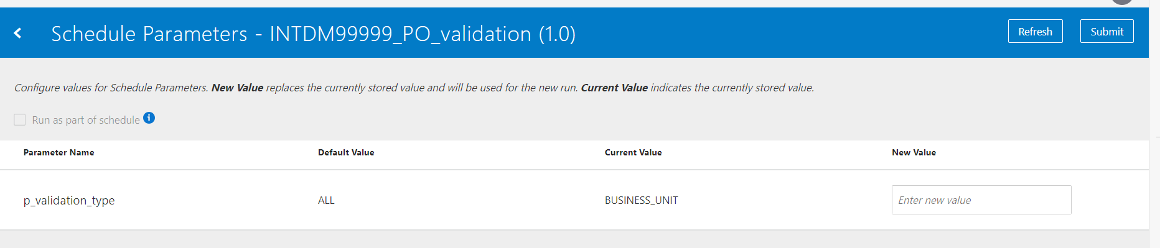

Integrations starts with the deletion of all the data from following tables using db adapters.

Table Names:

1. xxmx_legal_entities
2. xxmx_hr_location
3. XXMX_PURCHASING_LINE_TYPES
4. XXMX_PROJECTS
5. xxmx_business_units
6. xxmx_payment_terms
7. xxmx_po_category_item
8. XXMX_EXPENDITURE_TYPE
9. XXMX_EXPENDITURE_ORG
10. xxmx_po_project_Combo
11. xxmx_person
12. xxmx_UOM
13. xxmx_AGENT_BU

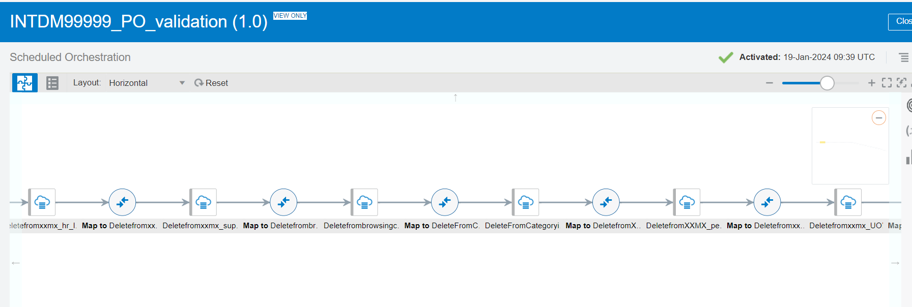

Then Integration calls the report from fusion environment, output of the report gets coverted from encodedbase64 to opaque schema. Read operation then uses the file refernce from write response and convert it into readable format and then data gets inserted into above tables.

Below are the list of reports that are being called.

1. /Custom/Maximise Data Migration/Reference Data Reports/Purchase_Orders/Business_Units Report.xdo
2. /Custom/Maximise Data Migration/Reference Data Reports/Purchase_Orders/Category_Hierarchy Report.xdo
3. /Custom/Maximise Data Migration/Reference Data Reports/Purchase_Orders/Exp_Org Report.xdo
4. /Custom/Maximise Data Migration/Reference Data Reports/Purchase_Orders/EXPENDITURE_TYPE REPORT.xdo
5. /Custom/Maximise Data Migration/Reference Data Reports/Purchase_Orders/HR LOCATIONS Report.xdo
6. /Custom/Maximise Data Migration/Reference Data Reports/Purchase_Orders/Legal_Entity Report.xdo
7. /Custom/Maximise Data Migration/Reference Data Reports/Purchase_Orders/PAYMENT_TERMS REPORT.xdo
8. /Custom/Maximise Data Migration/Reference Data Reports/Purchase_Orders/PERSON_NAME_REPORT.xdo
9. /Custom/Maximise Data Migration/Reference Data Reports/Purchase_Orders/PO_PROJECT_COMBO REPORT.xdo
10. /Custom/Maximise Data Migration/Reference Data Reports/Purchase_Orders/Procurement _Agent and BU Report.xdo
11. /Custom/Maximise Data Migration/Reference Data Reports/Purchase_Orders/PROJECTS_REPORT.xdo
12. /Custom/Maximise Data Migration/Reference Data Reports/Purchase_Orders/PURCHASING_LINE_TYPES REPORT.xdo
13. /Custom/Maximise Data Migration/Reference Data Reports/Purchase_Orders/Unit_Of_Measure Report.xdo

Once all the latest data is loaded from fusion into the above tables, a procedure is being called to insert the Maximise transformed data into XXMX_PO_VALIDATION table with status ‘N’ and then validate process will be called to validate all the setups.

Below is Package being called for the insertion into XXMX_PO _VALIDATION and validating the same.

If any difference is found between Cloud and Maximise then that setup check value is stamped with a status of ‘E’, else it is left with the original status of ‘N’.

Procedure:

1. xxmx_validate_PO_setup_pkg.insert_data
2. xxmx_validate_PO_setup_pkg.validate_data